Set up Cloud-Based Development Environment

Problem Statement:

To build and deploy applications in the cloud, we need a secure and consistent development environment. Instead of relying on local machines (which can vary across team members), we’ll provision a cloud-based virtual machine. This provides a scalable, standardized DevOps workspace accessible from anywhere.

Tools/Software Versions:

1. Operating System: Amazon Linux 2023 (on EC2)

2. Instance Type: t3.medium (2 vCPU, 4GB RAM)

3. AWS CLI: v2.28.21 (run on local machine)

4. Docker: v25.0.8 (installed on EC2)

5. Git: v2.50.1 (installed on EC2)

6. Python: 3.9.23 (installed on EC2)

7. Node.js: v20.19.4 LTS (installed on EC2)

Hands-on Steps:

Step 1: Create a Key Pair for SSH Access

Before we launch an EC2 instance, we need a key pair to log in securely. The command below will create a .pem file on your local machine. This file acts like the private key to unlock your server.

aws ec2 create-key-pair \
--key-name my-devops-keypair \
--query "KeyMaterial" \
--output text > my-devops-keypair.pem

chmod 400 my-devops-keypair.pem

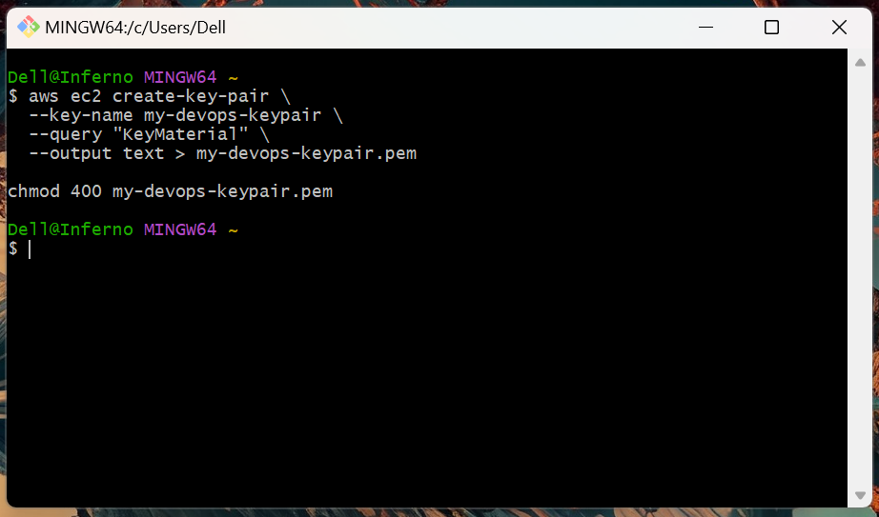

- The .pem file is created in your current directory.
- The chmod 400 command makes the file readable only by you (a requirement for SSH).

Step 2: Create a Security Group

Instances in AWS need security groups to control traffic. We’ll create one that allows SSH (for login) and HTTP (for serving apps later).

aws ec2 create-security-group \
--group-name devops-sg \
--description "DevOps environment security group"

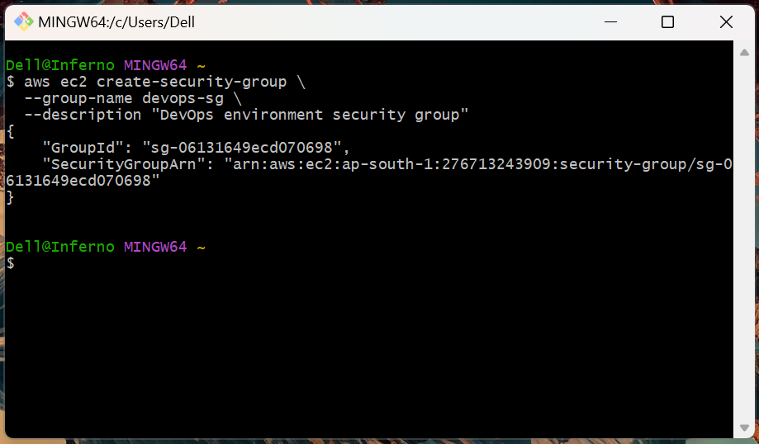

aws ec2 authorize-security-group-ingress \
--group-name devops-sg \
--protocol tcp --port 22 --cidr 0.0.0.0/0

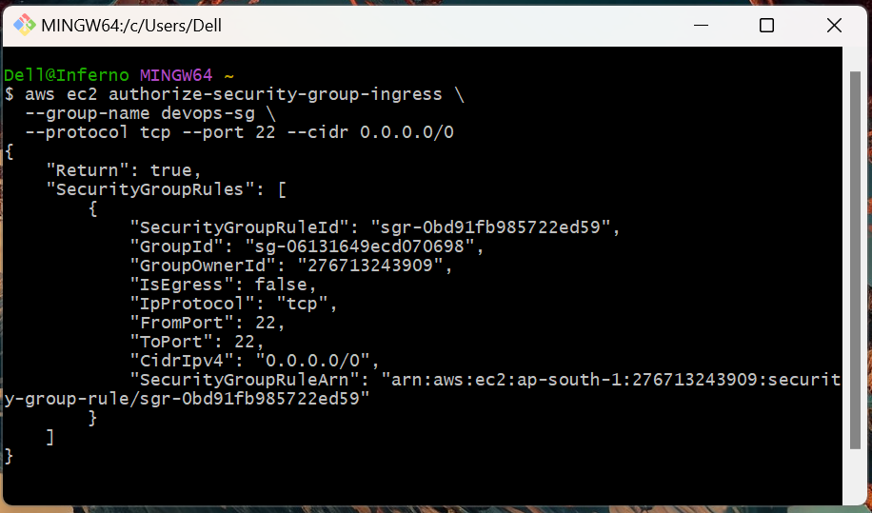

aws ec2 authorize-security-group-ingress \
--group-name devops-sg \
--protocol tcp --port 80 --cidr 0.0.0.0/0

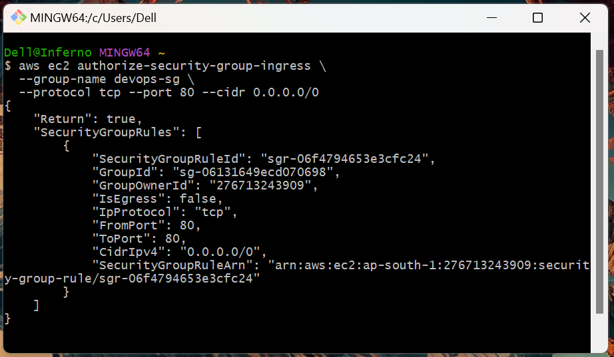

Step 3: Launch EC2 Development Instance

Now we provision the EC2 VM that will host our DevOps environment.

aws ec2 run-instances \
--image-id ami-0861f4e788f5069dd \
--count 1 \
--instance-type t3.medium \
--key-name my-devops-keypair \
--security-groups devops-sg \
--tag-specifications 'ResourceType=instance,Tags=[{Key=Name,Value=DevOps-Environment}]'

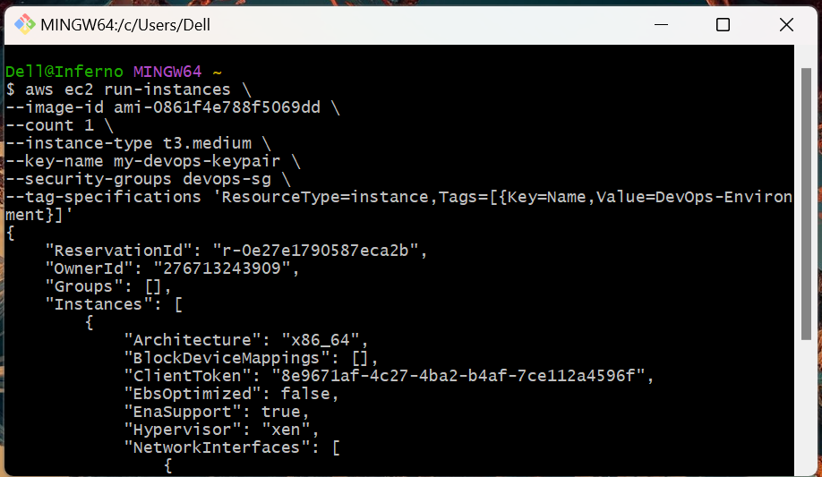

Head over to the EC2 Instances to check for the running instance.

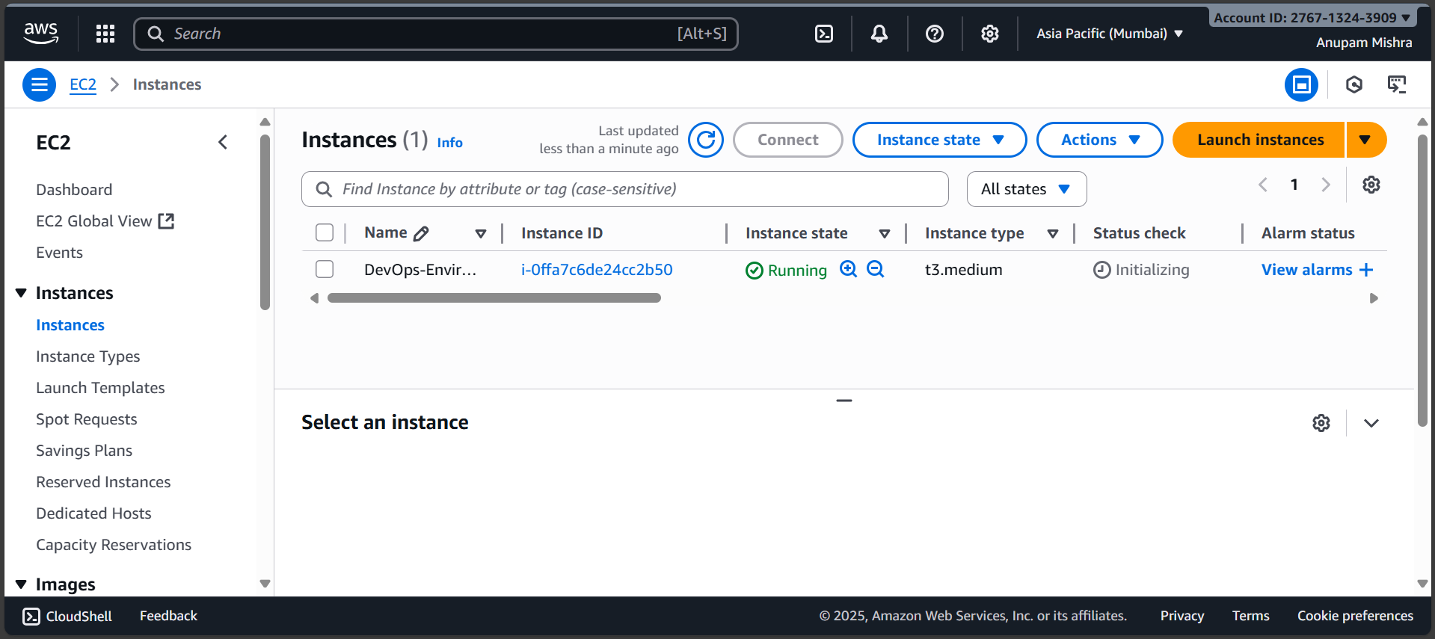

Step 4: Retrieve Instance Public IP Address

We need the public IP of the instance to connect to it.

aws ec2 describe-instances \
--filters "Name=tag:Name,Values=DevOps-Environment" "Name=instance-state-name,Values=running" \
--query "Reservations[*].Instances[*].PublicIpAddress" \

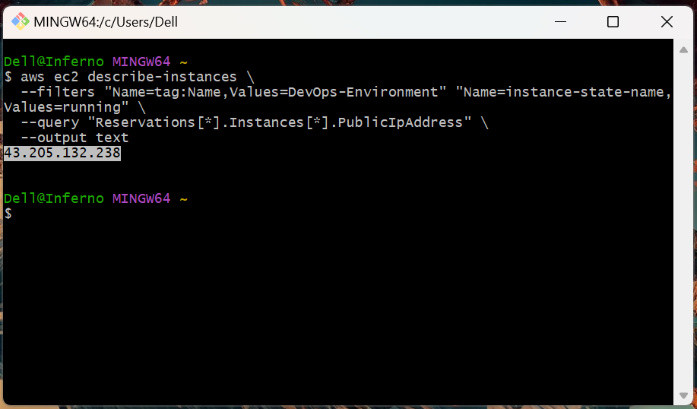

Step 5: Connect to Development Instance

With the key pair and public IP ready, we can now SSH into our EC2 instance.

ssh -i my-devops-keypair.pem ec2-user@43.205.132.238

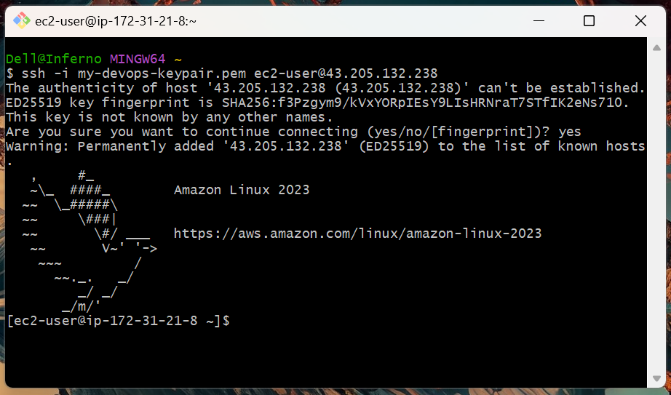

- The user is ec2-user for Amazon Linux.
- If the connection works, you’ll see a welcome message.

Step 6: Update System Packages and Install Development Tools

Now we are inside the EC2 VM. We’ll install Docker, Git, Python, and Node.js to prepare the environment.

# Update packages
sudo yum update -y

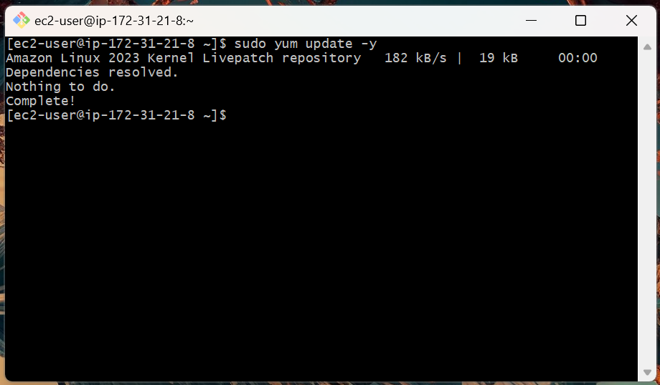

# Install Docker
sudo yum install -y docker

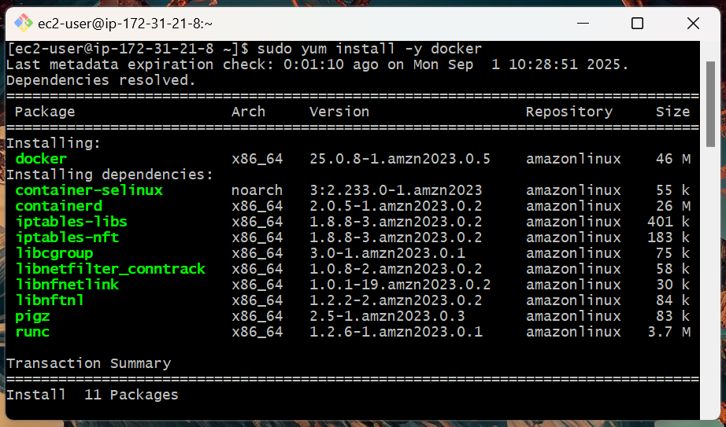

sudo systemctl start docker
sudo systemctl enable docker
sudo usermod -aG docker ec2-user

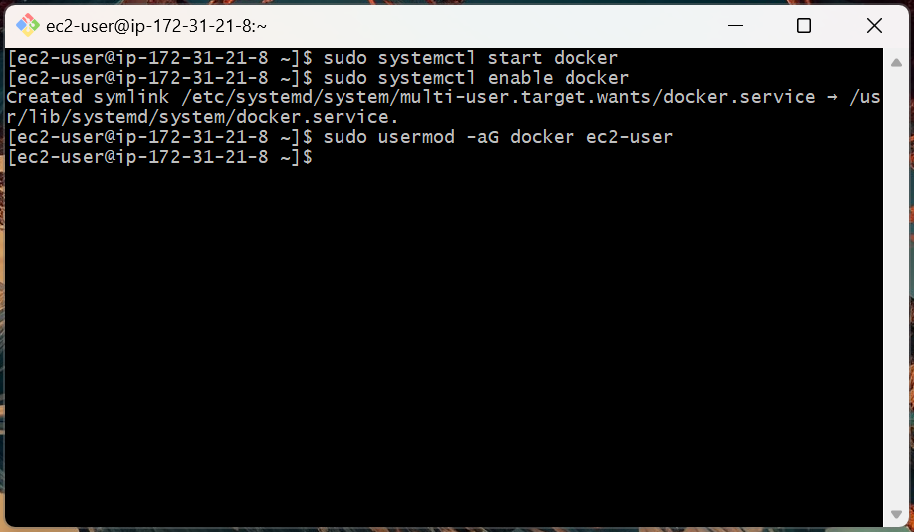

# Install Git and Python
sudo yum install -y git python3-pip

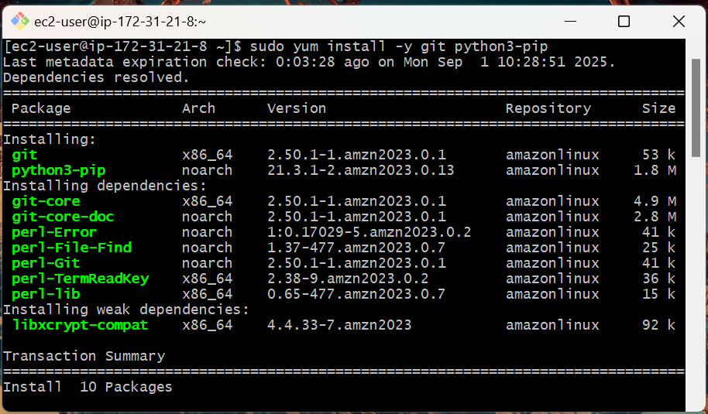

# Install Node.js
curl -fsSL https://rpm.nodesource.com/setup_20.x | sudo bash -

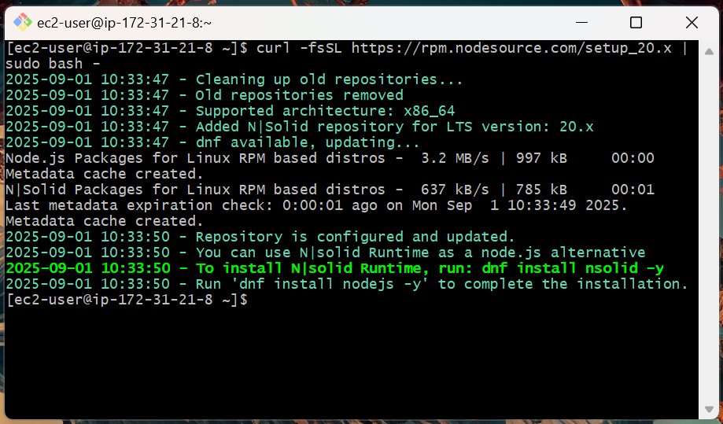

sudo yum install -y nodejs

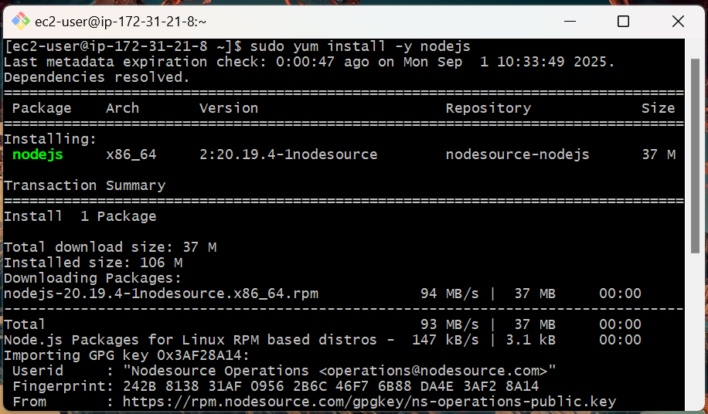

Step 7: Configure the Development Workspace

Finally, we’ll set up a workspace and configure Git. This personalizes your environment for development.

# Create workspace directory
mkdir ~/workspace && cd ~/workspace

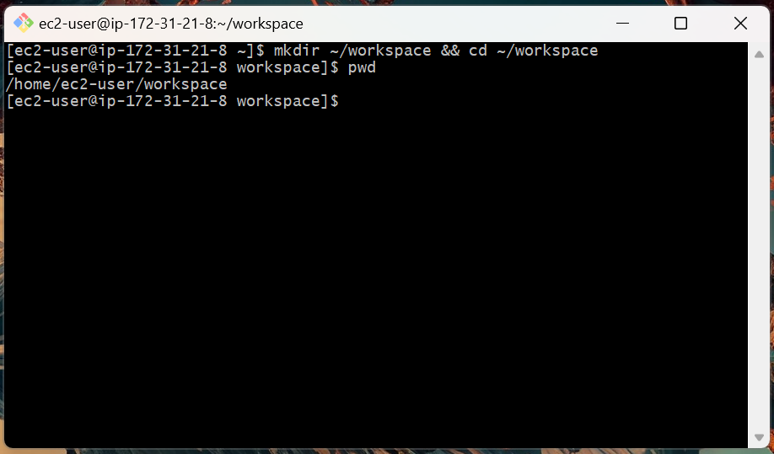

# Configure Git
git config --global user.name "anupamateduhubspot"
git config --global user.email "anupam.m@eduhubspot.com"

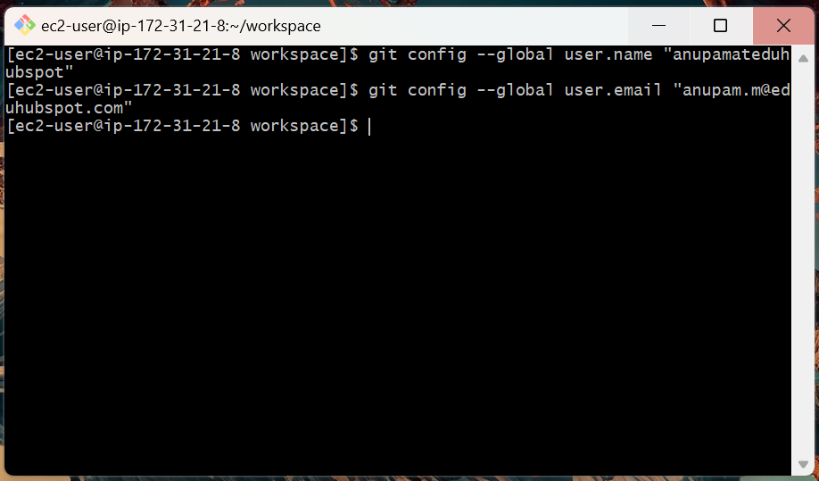

# Test Docker without sudo
docker run hello-world

At this stage, if we try docker run hello-world, we’ll likely hit a permission denied error. By default, only root can talk to the Docker daemon. To fix this, we’ll add the ec2-user to the docker group and apply the changes.

sudo usermod -aG docker ec2-user
newgrp docker

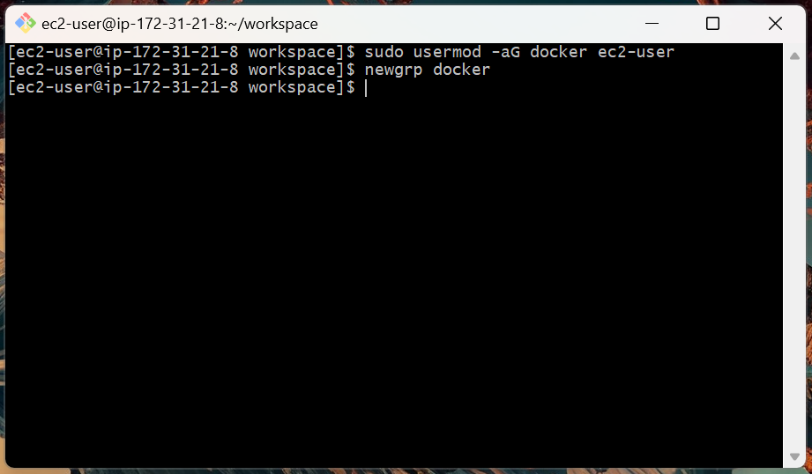

This makes sure the current user can run Docker commands without needing sudo.

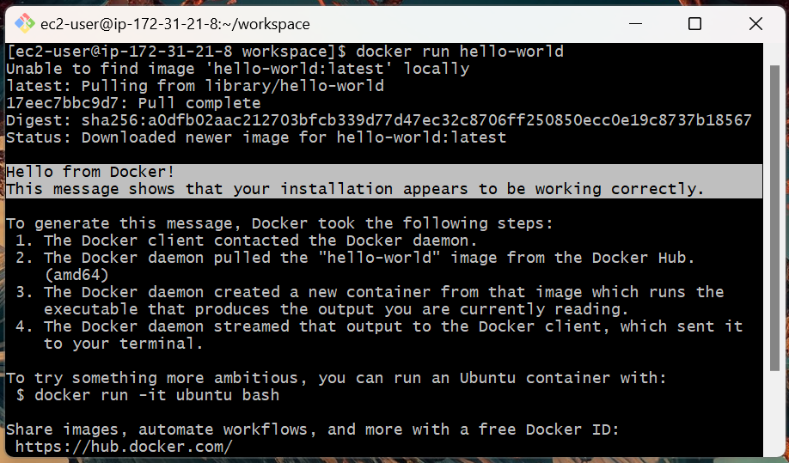

Topics Covered:

1. Created a secure SSH key pair and security group locally.

2. Launched an Amazon Linux 2023 EC2 instance.

3. Installed and verified essential DevOps tools inside the instance.

4. Fixed Docker permissions for non-root usage.

5. Configured a personal workspace and Git identity.

